Jakub Wojciechowski 49872
Gold or Foreign Currency? Protecting Savings from Inflation in Poland (2013–2026)
Mini Project – Network and Business Analytics

1. Introduction

1.1 Introduction of problem and objective
Many Polish households and small firms keep their savings and cash reserves in złoty. Inflation makes this money worth less every year and the złoty can also lose value against other currencies. So a simple but important business question is: where should savings be kept so they do not lose their value – in PLN cash, in a foreign currency (EUR, USD, CHF or GBP) or in gold?
The objective of this project is to collect real data that can answer this question and to explore it with exploratory data analysis (EDA). I used a theory-first approach: I started with the business problem and then collected the data needed to solve it. The results can help a household or a small firm decide how to keep its savings to protect their value.

1.2 Introduction of data
I collected three types of data: daily gold prices, daily exchange rates of four main currencies and monthly inflation in Poland. All of them are official, structured, secondary data. Together they form a set of related time series that covers almost 14 years (Table 1).
Table 1. Data used in the project
Source | Variable | Unit | Frequency | Period | Observations
NBP API | Gold price | PLN per 1 gram | Daily | 2 Jan 2013 – 16 Oct 2026 | 3,479
NBP API (table A) | EUR, USD, CHF, GBP exchange rates | PLN per 1 unit | Daily | 2 Jan 2013 – 16 Oct 2026 | 3,480 each
Eurostat | HICP price index for Poland | 2015 = 100 | Monthly | Jan 2013 – Sep 2026 | 165
In total the daily table has 3,480 days and about 17,400 price values, plus 165 months of inflation. Several related time series over a long period make it possible to compare the assets and to see how they behaved during major events, like the Swiss franc crisis in 2015, COVID-19 or the war in Ukraine.

2. Method of data collection
All data was collected with Python in a Jupyter notebook, using APIs. Gold prices and exchange rates come from the public API of the National Bank of Poland (NBP). It is free, needs no API key and returns data in JSON format. The API has two limits: one request can return at most about one year of data and it does not accept dates in the future. So I wrote a loop that downloads the data year by year, from 2013 to 2026 (the last year ends on 16 October 2026). This gave 14 requests for gold and 56 requests for the four currencies. For each request the code checks the status code and waits one second before the next one. Gold prices in the API start in 2013, so this is the start of the whole project.
The exchange rates were first saved in long format – date, currency, rate – and then changed to one column per currency. After that, gold and currencies were joined by date into one daily table.
Inflation comes from Eurostat and was downloaded with the eurostat Python package. Here I found a practical problem: in 2026 Eurostat moved to a new product classification and the old table (prc_hicp_midx) stops in December 2025. So I used the new table prc_hicp_minr. I downloaded the full table (about 100,000 rows for all countries and product groups) and kept only the total index for Poland from January 2013. All collected data was saved in CSV files.

3. EDA of data

3.1 Data issues and how I handled them
Before the analysis I checked the data for missing values, duplicates and gaps in dates. Table 2 shows what I found and what I did.
Table 2. Data issues
Issue | What I found | How I handled it
Missing values | 1 gold price missing – 12 Nov 2018 (an extra public holiday in Poland, but NBP still published exchange rates) | Filled with the price from the day before
Duplicates | None | No action needed
Gaps in dates | 670 three-day gaps (weekends) and 105 gaps of 2, 4, 5 or 6 days (public holidays) | Left as they are – there is no trading on these days, so they are not missing values
Daily vs monthly data | Prices are daily, inflation is monthly | Monthly averages of prices, matched with inflation by month
Different end dates | Prices end on 16 Oct 2026, inflation in Sep 2026 | October 2026 removed from the inflation part (165 months left)
Outliers | Very big daily moves, e.g. CHF +15.3% on 15 Jan 2015 | Kept – they are real market events, not data errors

3.2 Descriptive statistics
Table 3 shows the main statistics of prices. Prices have very different levels (gold costs 116–625 PLN per gram, the euro 4–5 PLN), so to compare risk I also calculated daily log returns in % and their yearly volatility (standard deviation × √252 trading days).
Table 3. Descriptive statistics of prices in PLN (2 Jan 2013 – 16 Oct 2026)
Asset | Mean | Median | Std. dev. | Min | Max | Change 2013–2026 | Yearly volatility
Gold | 228.46 | 190.02 | 110.26 | 116.35 | 624.92 | +213.5% | 17.4%
EUR | 4.35 | 4.29 | 0.17 | 3.98 | 4.96 | +7.4% | 5.4%
USD | 3.80 | 3.80 | 0.37 | 3.00 | 5.04 | +26.6% | 9.9%
CHF | 4.11 | 4.07 | 0.44 | 3.31 | 5.12 | +40.0% | 8.8%
GBP | 5.14 | 5.06 | 0.30 | 4.59 | 6.08 | +3.4% | 8.5%

- Gold changed the most: from 166 to 520 PLN per gram (+213.5%). Currencies changed much less and the euro was the most stable.
- The mean gold price is much higher than the median (228 vs 190 PLN), because gold was much more expensive in the last years.
- Gold is also the riskiest asset: its yearly volatility (17.4%) is three times higher than for the euro (5.4%).
- Average daily returns are close to zero for all assets, but the returns are not normally distributed. The Shapiro-Wilk test gives p < 0.001 for all of them and all have fat tails (kurtosis between 3.3 and 6.9, while a normal distribution has 0; for CHF even 170 because of one extreme day).
- The biggest daily moves match known events: CHF +15.3% on 15 Jan 2015 (the Swiss central bank stopped holding the franc at 1.20 per euro), gold −9.7% on 16 Apr 2013 (gold price crash), the days after the Brexit vote in June 2016 (GBP −3.7%, gold +7.7%) and the weeks after Russia attacked Ukraine (EUR +2.6% and USD +4.0% on 7 Mar 2022).

3.3 Visualization
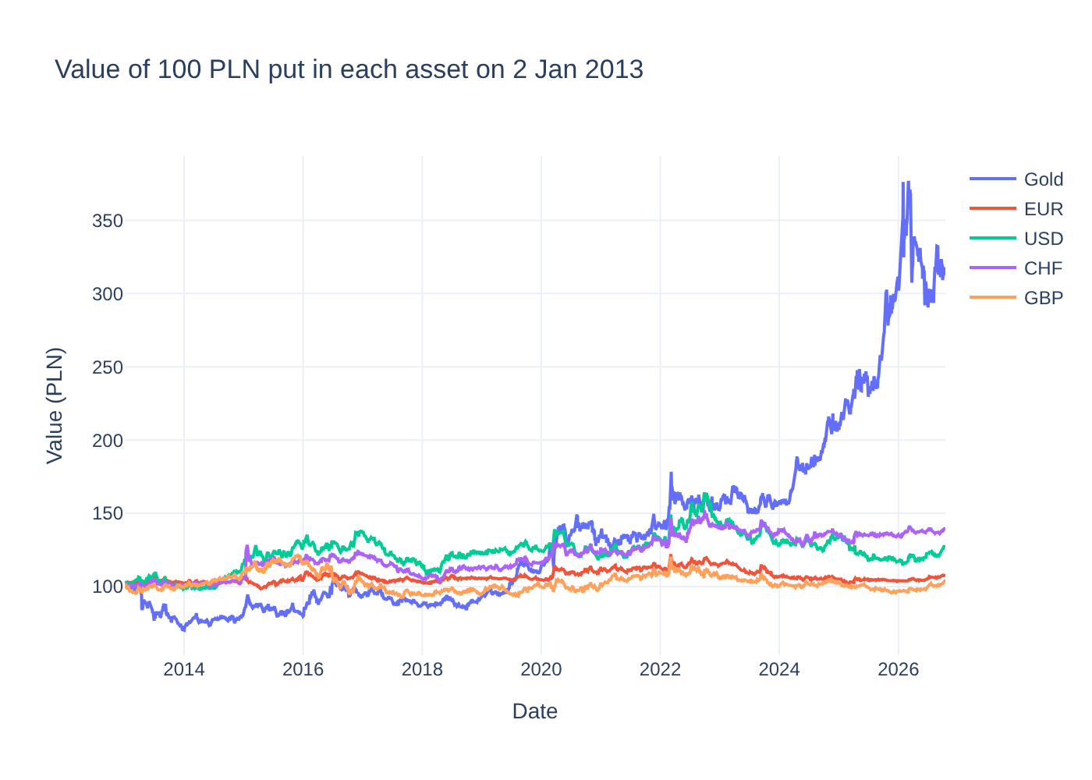
Figure 1. Value of 100 PLN put in each asset on 2 January 2013 (before inflation)
Gold grew the most, especially from 2024. At its peak on 3 March 2026, 100 PLN in gold was worth 377 PLN and now it is worth 313 PLN. But gold also had long falls – in 2013 it lost about 30%. Currencies moved in a much narrower range (about 92–164 PLN).

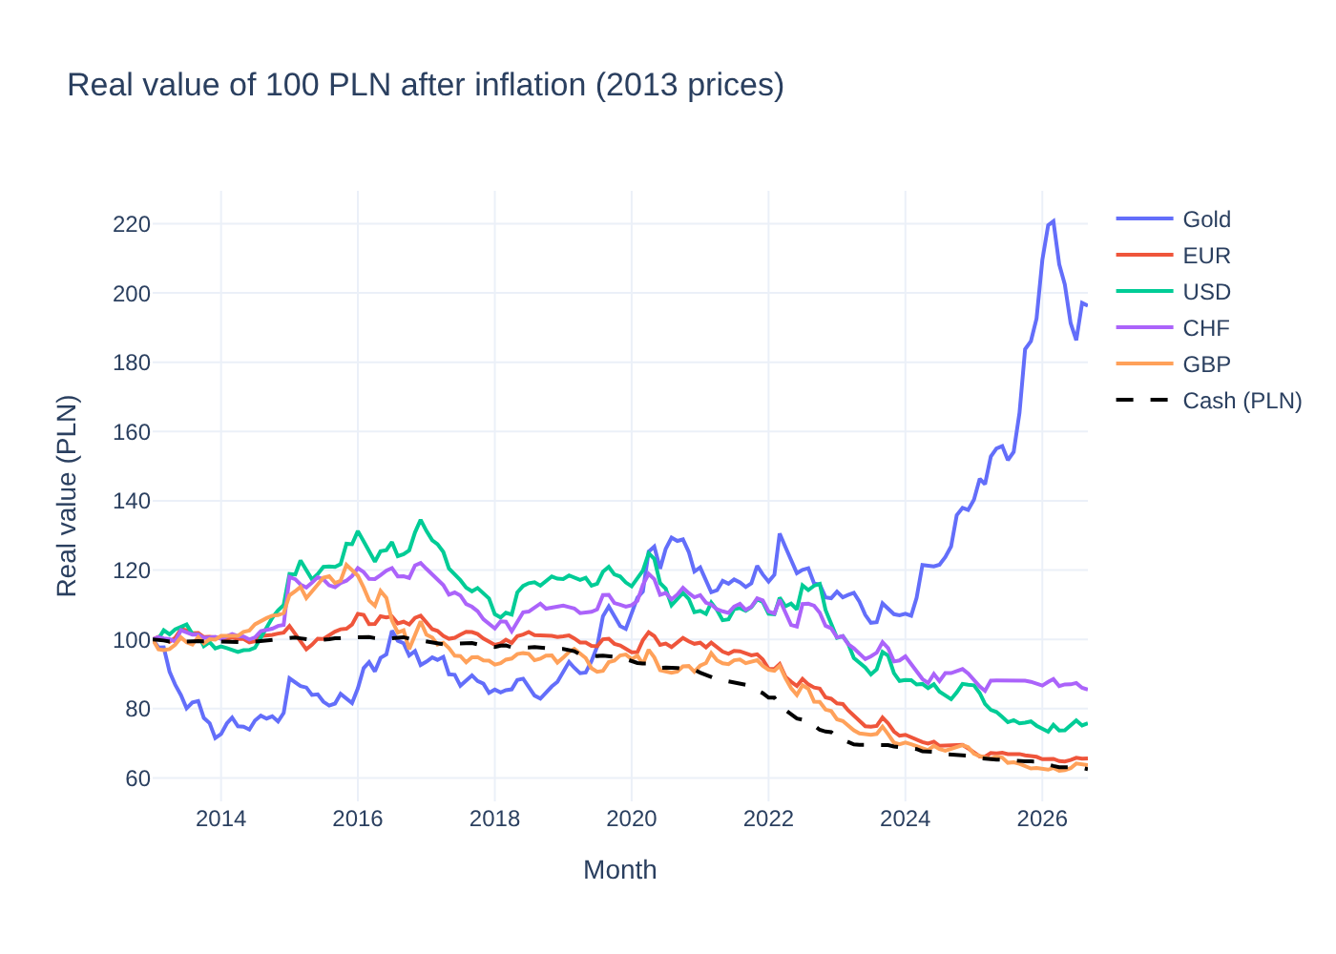
Figure 2. Real value of 100 PLN after inflation (in January 2013 prices)
This is the key result of the project. Prices in Poland went up by 60%, so 100 PLN kept in cash is worth only 62.5 PLN today. All currencies also lost real value: CHF 85.5, USD 75.8, EUR 65.6 and GBP 63.6 PLN. Only gold protected the savings – it is worth 196.3 PLN, almost twice the starting value. But not all the time: from 2013 until mid-2019 gold was below 100 almost every month, so for about six years it also lost real value.
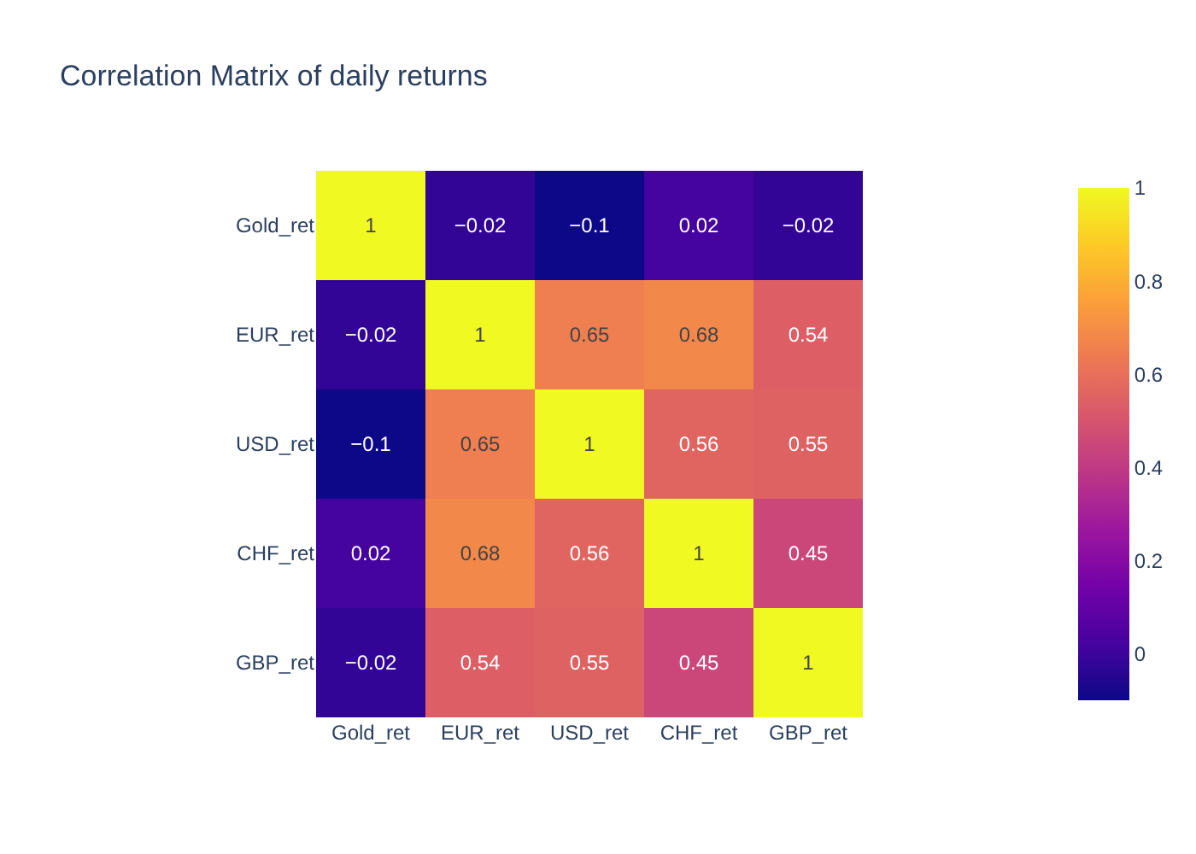
Figure 3. Correlation matrix of daily returns
Gold is not correlated with the currencies (from −0.10 to 0.02), while the currencies move together (0.45–0.68). When the złoty gets weaker, it gets weaker against all of them. It means that gold can diversify savings, while holding several currencies gives less diversification.
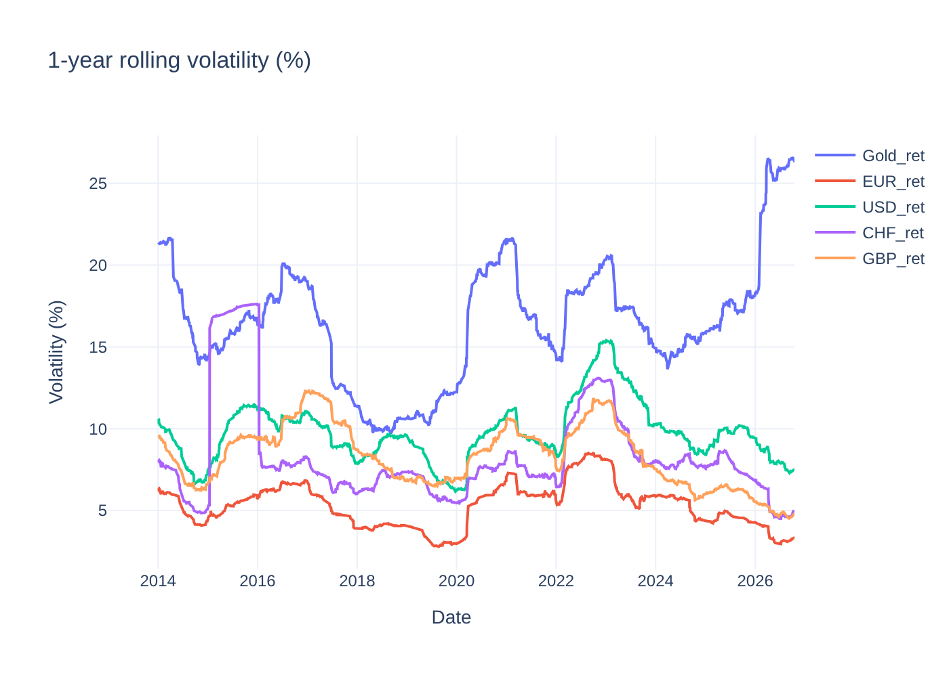
Figure 4. 1-year rolling volatility of daily returns (%)
Risk changes over time. The franc was most volatile in 2015, the pound in 2016–2017 (Brexit) and the dollar and the euro in 2022 (war in Ukraine). Gold volatility is now the highest in the whole period (about 26%, compared to about 10% in 2018). Histograms and box plots in the notebook confirm fat tails and many outliers for all assets.

4. Conclusion: what is to be done with the data in future
The EDA gives a clear answer to the problem. Savings kept in PLN cash lost about 37% of their value since 2013 and foreign currencies did not protect them either. Gold was the only asset that kept and even increased its real value, but with much higher risk and long periods of losses. Because gold is not correlated with currencies, it can be a good part of savings, but not the only one.
The data is ready for further analysis. In the future I want to:
- Predict future gold prices and exchange rates (for example ARIMA).
- Use regression to check if higher inflation goes together with higher gold prices.
- Compare gold and currencies with other ways to save money, for example a bank deposit.
- Check if mixing gold and currencies (for example half and half) lowers the risk.
- Check how the results change with a different start year, because 2013 was a bad year to buy gold.
Attached files: Jupyter notebook (Wojciechowski_Jakub_49872_Mini_Project_code.ipynb) and 5 CSV files with the collected data.

